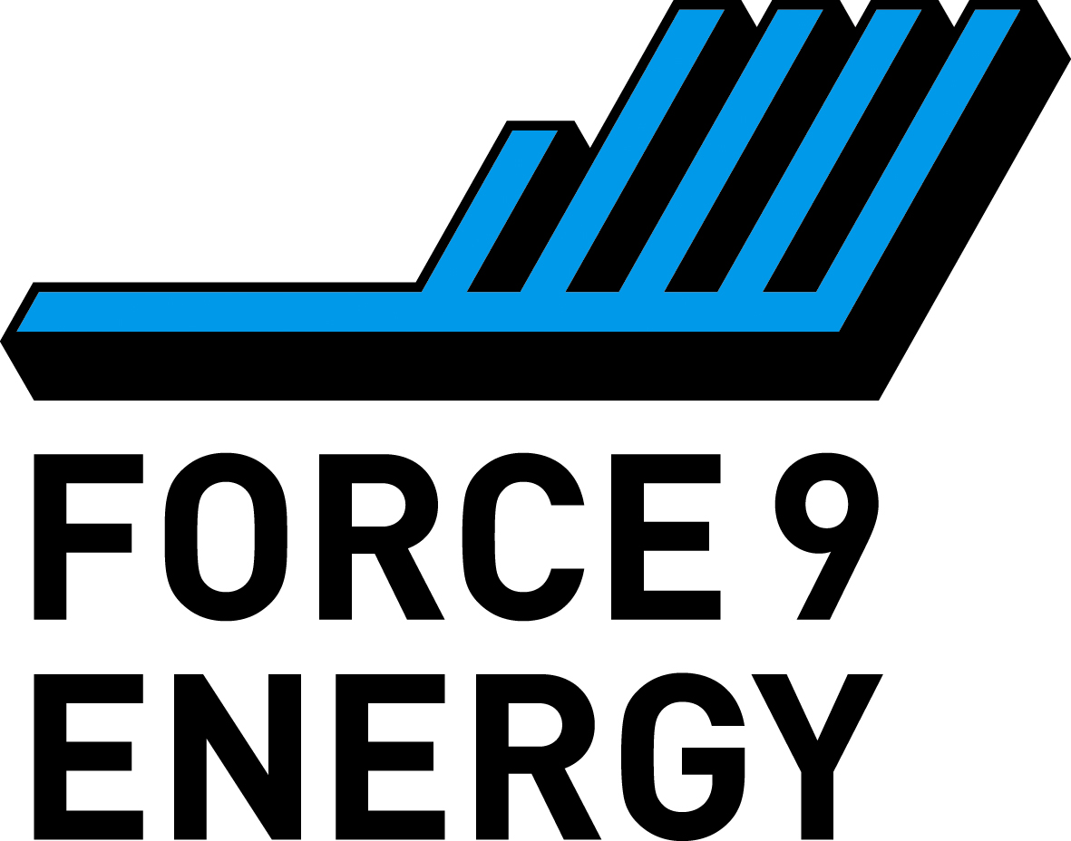
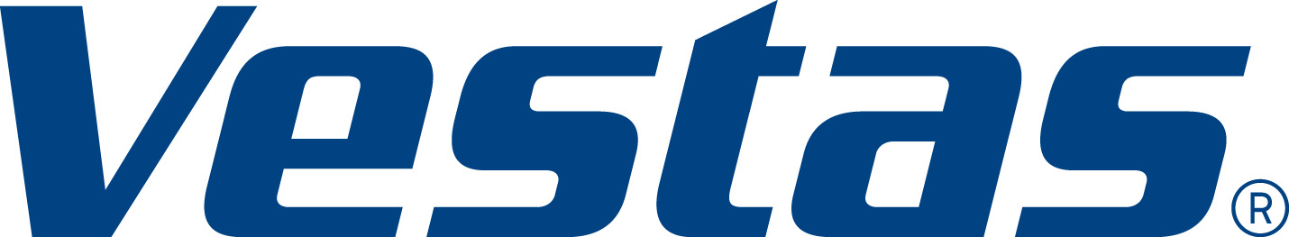

Dalmacallan Wind Farm: Feedback Form

Thank you for attending the second public exhibition on the proposed Dalmacallan Wind Farm. We appreciate your time and invite you to share your feedback through this short survey. Your responses will help us better understand community views as we finalise the project.

Please note that all information provided will be handled in accordance with data protection regulations and used only for the purposes of this project.

All questions are optional. If you have any questions about the survey or how your information will be used, please contact us at dalmacallan@mucklemediagroup.co.uk.

The exhibition displays can be downloaded from the project website - www.dalmacallan.vestaswindprojects.com. If you do not have online access, please let a member of the project team know and we can arrange for these to be sent to you by post.

Forms can be handed directly to our project team or posted to: Spey, Unit 14, Forres Enterprise Park, IV36 2AB. Any comments made will be collected and used by Force 9 Energy, not the determining authority. Representations to the determining authority will be possible following the submission of a planning application.

Please provide feedback by Friday 23rd October 2026.

We value your input and thank you for contributing to this process.

Name: | Email:
Phone: | Address:

- Approximately how far do you live from the site? (tick as appropriate)

Within 2km
Within 5km
Within 10km
Beyond 10km

- Did you attend the first public consultation event in October 2025?

Yes
No

- Did you find today’s exhibition helpful and informative?

Yes
No

- Since the public consultation events held in October 2025 a number of changes have been made to the proposed design of the project and its access. These came about as a consequence of engagement with local people, statutory stakeholders and further environmental work.
Do you consider that the design has improved and do you have any other comments on the design?

- Throughout the planning process we will continue to welcome ideas on how a Community Benefit Fund could be managed to maximise benefits for the local area. Do you have any suggestions on how the funds could be administered, for example as part of existing arrangements or through a new unique process?
What types of projects or initiatives would you like to see supported by the Community Benefit Fund? Are there any specific community needs or challenges that the fund could help address?

- Do you think communities in the area would be interested in shared ownership of the project?

Yes
No

- If you answered yes, do you have any initial ideas or suggestions for how community shared ownership could work for communities in the local area?

- Do you have any other comments?
By ticking this box you are agreeing for your data to be processed in accordance with our privacy policy.
Please tick here to be kept updated about the project. Please provide your email address above for us to contact you.

DISCLAIMER
PRIVACY STATEMENT
Muckle Media is conducting this consultation event on behalf of Force 9 Energy and
Vestas. We only collect personal information, such as your name, address, telephone
number and email address when you provide it to us. Your personal data will be treated
in the strictest confidence and only shared within the Force 9 Energy planning team. It
will be used for specific purposes in relation to the development of the proposal.

Your identifiable personal data will not be used for other purposes without your consent.
Please note all fields are voluntary. Your personal data will be stored securely until
completion of the planning process, after which this information will be deleted. It will
not be forwarded to any third parties without your consent. You can contact us at any
time to request the deletion of your information. Please get in touch with us at
dalmacallan@mucklemediagroup.co.uk

